This project aims to copy data from Azure SQL Database to Azure Storage Account using Dynamic pipelines in Azure Key Synapse Analytics. Azure Key vault is used for authentication.

1Authenticating linked service using Key Vault

2Creating dynamic source dataset

3Creating dynamic paramters for sink dataset

Configuring dynamic parameters for source pipeline

5Configuring dynamic parameters for sink pipeline

Triggers for diiferent parameters

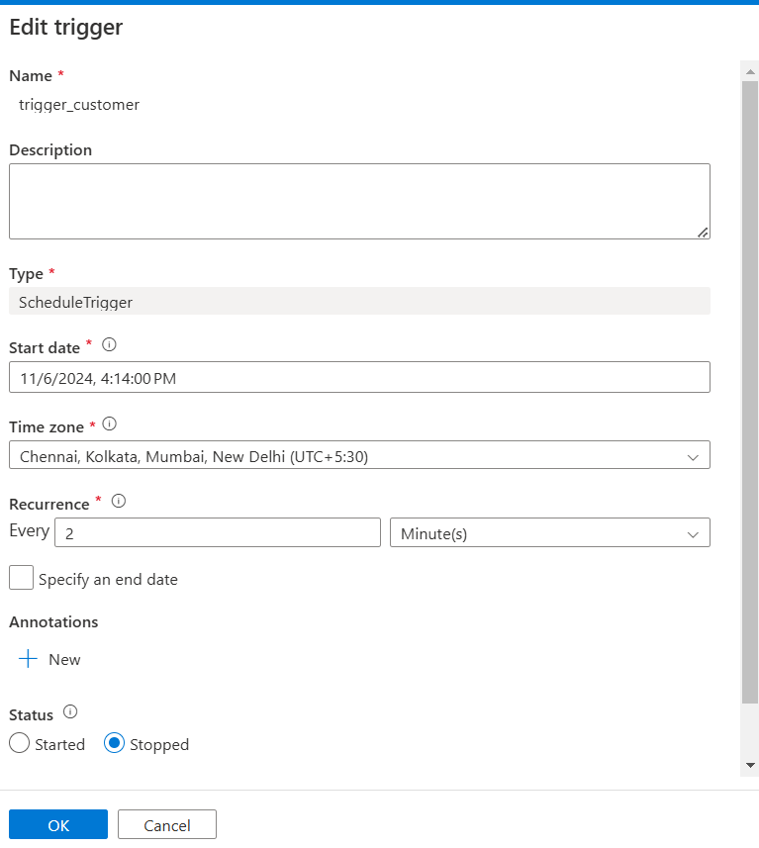

7Output after pipeline execution

8Creating external tables

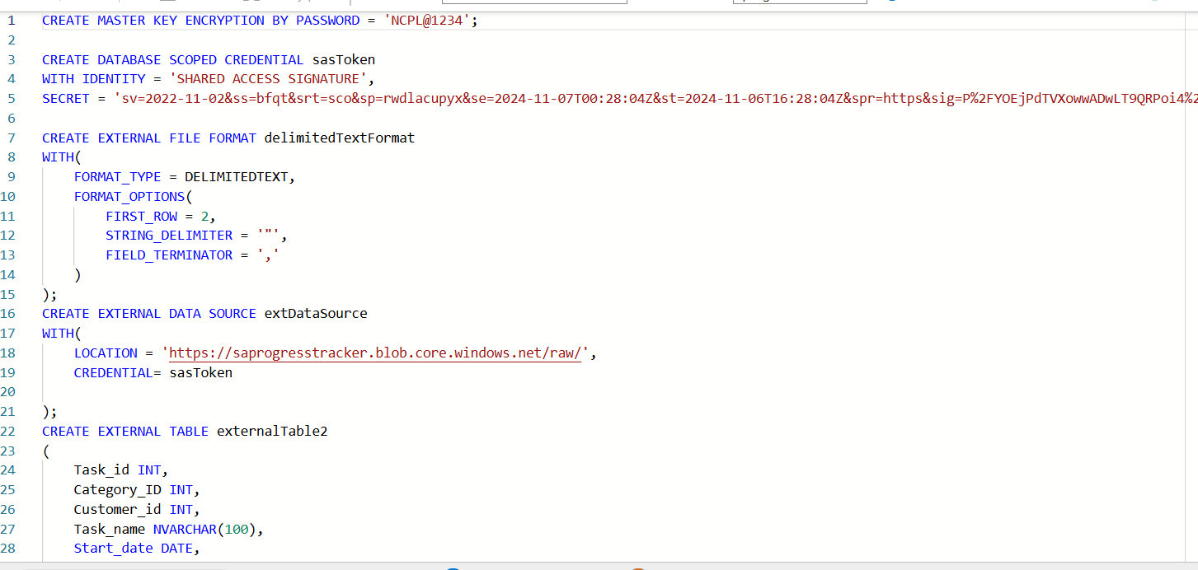

9.Querying external tables

